There are two main different strategies in deployment.

1. Blue-Green deployments
2. Canary deployments
3. **Blue-Green deployments**

This is a software rollout method that can be used to reduce the impact of any issues during the rollout of a new software release.

Blue Release is your current production environment.

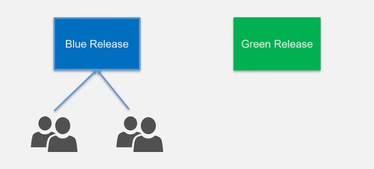

The new release is release to a limited set of users for testing.

* Gradually over the time, all users are migrated to the Green release.
* And then at the end, this becomes your Blue release.
* If there are any issues in the new release, users can easily switch back over to the Blue Release.

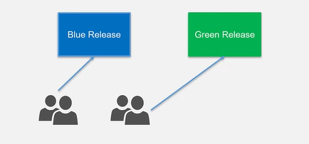

**Canary Deployments:**

In this deployment first we test and deploy on one set of servers once it is fine then we go ahead to the others.

